

**Title Page**

**Project Title:** Assessing BI Maturity and Developing a BI Dashboard for Superb Motors

**Team Members:**

* Brandon Erickson 665316
* Nyabuto David Mouti 666023
* Ryan Rumanzi 665298
* Waimiri Joseph Romeo 665258

**Date of Submission:** 10th July 2024

**Table of Contents**

1. Executive Summary
2. Introduction
3. Selection of SME
4. BI Maturity Assessment
5. Data Identification and Analysis
6. BI Report and Dashboard Design
7. Implementation Plan
8. User Documentation/Manual
9. Feedback and Evaluation
10. Future Recommendations
11. Conclusion
12. References
13. Appendices

**Executive Summary**

This comprehensive report details the development and implementation of a Business Intelligence (BI) solution tailored for Superb Motors enterprise based in Nairobi. The primary objective was to assess the organization's BI maturity level and subsequently design a dynamic dashboard to enhance decision-making processes and operational efficiency. The analysis revealed significant gaps in data integration and highlighted the necessity for advanced BI tools. The project culminated in the successful deployment of a BI dashboard, facilitating real-time data insights and enabling data-driven decision-making, which markedly improved operational performance.

**Introduction**

**Background of the Project**

Superb Motors, a car rental service provider in Nairobi, aims to leverage Business Intelligence (BI) to optimize its service delivery and operational efficiency. The project focused on evaluating the company's BI maturity and implementing a dashboard to enhance decision-making processes.

**Importance of Business Intelligence (BI) for SMEs**

For small and medium enterprises (SMEs), BI is essential in transforming raw data into actionable insights, leading to informed decision-making, enhanced customer service, and increased profitability. For superb motors, BI can significantly improve resource utilization and elevate customer satisfaction to give them an edge in their industry as they can see changes and developments in their operations and adapt accordingly with informed insights.

**Project Objectives and Scope**

The project's objectives were to analyze Superb Motors current performance, identify areas for improvement, and implement a BI dashboard. The scope encompassed evaluating car rental trends, understanding customer preferences, and assessing financial performance.

**Selection of SME**

**Description of superb Motors.**

Superb Motors is a reputable car rental company in Kilimani Nairobi, offering a diverse fleet of vehicles for rental purposes. The company's focus is on delivering high-quality services to both individual and corporate clients. The company was formally registered in 2020. The first founder operated the company informally from Mombasa. In 2020, the company decided to approach investors and expand its fleet and venture into new markets. With over 250 vehicles ranging from SUVs, Hatchbacks, Sedans, and cabriolets, the company serves over 150 clients in Diani, Kisumu, Mombasa, Nairobi, Nyali, Eldoret.

**Initial Contact and Business Understanding**

Upon establishing contact with the company management, the Initial meetings provided deep insights into their business processes and existing challenges.  
 Key areas identified for BI implementation included customer data management, rental trends analysis, and financial performance tracking.

**Overview of the car industry.**

The car rental industry plays a crucial role in providing travelers with the convenience and flexibility of having their vehicle when traveling. Often, a subset of individuals who fly to new locations prefer the autonomy and comfort of driving themselves over relying on taxis or public transportation. Renting a car allows for personalized travel plans, the freedom to explore at one's own pace, and the ability to access destinations that may be inconvenient or inaccessible by other means. This industry addresses the needs of business travelers, tourists, and those needing temporary vehicles for various reasons, including during repair and maintenance of their own cars or simply looking to experience a different vehicle for one reason or another.

Despite its advantages, the car rental business faces significant challenges. It is capital intensive, requiring substantial investment in purchasing and maintaining the diverse fleet of vehicles to meet customer demands. Additionally, the industry must manage the risks associated with trusting strangers with valuable assets. This includes ensuring the vehicles' security, handling potential damages, and managing insurance costs. To mitigate these risks, car rental companies implement stringent policies, use advanced tracking technologies, and often require comprehensive insurance coverage. These measures help protect their investments while offering a vital service that enhances the travel experience for countless individuals.

**Target market.**

The target market for this car rental business is locations with airports, primarily focusing on providing convenient transportation to those traveling to towns the business has operations. The business was initially established by its founder in Mombasa, where it catered primarily to airport travelers. The niche market revolves around offering the convenience of having your own car upon arrival at a new destination within Kenya. Notably, all the destinations served by this business are either tourist towns or locations with major airports in Kenya, ensuring that travelers can enjoy seamless transportation from the moment they land.

**Products and Services**

Superb motors makes up a fleet of assorted vehicles to cater to all customer preferences. The fleet includes SUVs, Hatchbacks, Sedans, Convertibles, and Trucks. Clients can also request for a driver.

* A hatchback is a car with a rear door that swings upward to provide access to the cargo area, which is typically integrated with the passenger area.
* A sedan is a passenger car with a separate compartment for luggage, a fixed roof, and typically four doors.
* An SUV (Sport Utility Vehicle) is a larger vehicle designed for both on-road and off-road driving, often with higher ground clearance and available in four-wheel drive.
* A truck is a motor vehicle designed to transport cargo, typically with a larger and open cargo area in the back.
* A convertible is a car with a roof structure that can be 'converted' to allow open-air or enclosed driving, usually by folding or retracting the roof.

The car makes and model available for rental include:

Benz: includes Mercedes and AMG brands.

BMW: includes BMW and Alpina brands.

Mazda

Nissan: includes Nissan and Infiniti brands.

Toyota: includes Toyota and Lexus brands.

VW

**Current Business Processes.**

These are the current business processes;

Fleet Management:

* Acquisition: Purchasing or leasing vehicles for the rental fleet.
* Maintenance: Regular servicing, repairs, and upkeep of vehicles to ensure they are in good condition.
* Disposition: Selling or disposing of older or less-used vehicles.

Customer Management:

* Customer Acquisition: Marketing and promotional activities to attract new customers.
* Reservations and Bookings: Managing reservations, either online or through a call center.
* Customer Service: Providing support and addressing customer inquiries and complaints.

Rental Operations:

* Check-in/Check-out: Process of handing over the vehicle to the customer and receiving it back at the end of the rental period.
* Inspection: Inspecting the vehicle for damage and cleanliness before and after the rental period.
* Billing and Payments: Managing rental charges, deposits, and processing payments.

Pricing and Revenue Management:

* Rate Setting: Determining rental rates based on factors like vehicle type, rental duration, and demand.

Insurance and Risk Management:

* Insurance Coverage: Managing insurance policies for the fleet and ensuring all vehicles are adequately covered.
* Accident Handling: Recording and processing any accidents or damages that occur during the rental period.
* Claims Management: Handling insurance claims and repairs for damaged vehicles.

Data Management:

* Data Collection: Gathering data on vehicle usage, customer preferences, and operational performance.
* Data Analysis: Analyzing collected data to identify trends, optimize operations, and improve customer satisfaction.
* Reporting: Generating reports for management to make informed decisions

**BI Maturity Assessment**

**BI Maturity Model**

The Gartner BI Maturity Model was selected to assess Superb motors BI capabilities. This model evaluates dimensions such as data management, technology utilization, and organizational processes.

**Methodology Used for the Maturity Assessment**

The assessment methodology included in-person and on-phone interviews with key stakeholders to collect data on existing BI practices and identify gaps.  
The interviews sort to uncover the following tasks.

**Detailed Findings of the BI Maturity Assessment**

**1. Inconsistent Data Management Practices:**

The assessment revealed that the car rental business lacks a standardized approach to data management across different branches. For example, the data collected from the Nairobi branch differs significantly from that of the Mombasa branch in terms of format, accuracy, and completeness. This is mainly due to the fact that most branches relied on manual data collection. This inconsistency has led to difficulties in compiling a cohesive dataset for analysis. Due to the inconsistent data, the data marts cannot show relationships between and within them, to visualize trendsImplement a standardized data management policy and centralized data repository to ensure consistency across branches.

Recommendation: Implement a standardized data management policy and centralized data repository to ensure consistency across branches.

**2. No Use of Advanced BI Tools:**

The business currently relies on basic spreadsheets for recording transactions and customer information. There is no use of advanced BI tools to analyze and visualize data, which means business decisions are not data-driven but based on stakeholders' instincts and opinions.

Recommendation: Adopt advanced BI tools like Power BI to create interactive dashboards and reports that can provide insights into business performance, trends, and customer preferences.

**3. Little Accountability and Record Tracking:**

There is a lack of accountability and proper record tracking within the company. This issue is evident from the repetitive data points in the dataset, which indicate insufficient data collection methods and a lack of unique identifiers for transactions.

Recommendation: Establish clear data entry protocols and unique identifiers for all transactions to improve record accuracy and accountability.

**4. Untrained Staff:**

Staff across various branches are not adequately trained in data management and analysis. This lack of training results in errors during data entry, inconsistencies in data recording, and an inability to utilize data effectively for decision-making. Provide comprehensive training programs for staff on data management best practices and the use of BI tools to enhance their capability in handling and analyzing data.

**5. Little to No Investment in Computing:**

The business has made minimal investments in computing infrastructure, leading to inefficiencies in data processing and analysis. Branches are using outdated software and hardware while some are using manual bookkeeping systems which hampers the ability to store, process, and analyze large volumes of data.

Recommendation: Invest in modern computing infrastructure, including up-to-date software and hardware, to support efficient data management and BI tool usage. This investment will enable faster data processing, better data security, and more effective data analysis capabilities.

**Gap Analysis and Areas for Improvement**

The gap analysis underscored the necessity for a formal data governance framework, investment in advanced BI technologies, and development of BI skills.

**1. Record Keeping**

**Current Issue**: The business has inconsistent and haphazard records that do not reflect its actions accurately and vary across branches.

**Steps for Improvement**:

1. Identify the Relevant Data based on KPIs:
   * The business should identify the data they need to collect in order to achieve their KPIs and optimize on their available resources.
2. Centralize Record Keeping:
   * Implement a centralized database system accessible by all branches to ensure consistency.
   * Use cloud-based solutions like Microsoft Azure, AWS, or Google Cloud for scalability and accessibility.
3. Standardize Data Entry Procedures:
   * Develop and enforce standardized procedures for data entry to ensure uniformity.
   * Use forms and templates to reduce errors and inconsistencies.
4. Implement Data Quality Checks:
   * Regularly audit the data for accuracy and completeness.
   * Use data validation tools and techniques to identify and correct errors.
5. Train Staff on Data Entry and Management:
   * Conduct training sessions on proper Data Entry and Management techniques and their complimentary architecture.
   * Sensitize on the importance of accurate record-keeping and the proper use of the new system.

**2. Investment in Computing and BI Tools**

**Current Issue**: The business lacks proper computing services and usable BI tools.

**Steps for Improvement**:

1. Assess Current IT Infrastructure:
   * Evaluate the current hardware and software infrastructure to identify gaps- the business uses an excel depend system that is not well curated and lacks qualified personnel to use it.
2. Invest in Modern BI Tools:
   * Purchase and implement BI tools such as Microsoft Power BI, Tableau, or QlikView.
   * Ensure the tools can integrate with existing systems and databases. The business should invest in a BI tool and the complimentary infrastructure to run and maintain the same.
3. Upgrade Computing Resources:
   * Invest in high-performance servers, workstations, and networking equipment.
   * Consider cloud-based solutions for flexibility and scalability, if the cost of in-house computing is too high, outsource it.
4. Implement Data Warehousing:
   * Create a data warehouse to consolidate data from different sources.
   * Use ETL (Extract, Transform, Load) processes to ensure data is clean and ready for analysis.

**3. Staff Training**

Current Issue: Staff need training on how to use the new computing investments.

Steps for Improvement:

1. Identify Training Needs:
   * Conduct a skills assessment to identify gaps in knowledge and skills related to BI tools and computing systems.
   * Hiring and training should be tailored to the business’s specific needs and culture.
2. Develop Training Programs:
   * Create comprehensive training programs that cover basic and advanced usage of the new BI tools.
   * Include practical hands-on sessions and real-world scenarios, integrate all necessary staff, and create a manual and protocol for each party to learn their required work.
3. Provide Continuous Learning Opportunities:
   * Offer ongoing training and support to keep staff updated on new features and best practices, and create a hands-on approach in which new staff are trained by specific individuals.
   * Encourage certification programs for staff to gain advanced skills.
4. Monitor and Evaluate Training Effectiveness:
   * Use feedback and performance metrics to assess the effectiveness of the training programs.
   * Make necessary adjustments to the training content and delivery methods.

5. Improvement of Customer-Business Interaction

**Steps for Improvement**:

1. **Implement Customer Feedback Systems**:
   * Use surveys, feedback forms, and direct customer interactions to gather feedback.
   * Implement online feedback portals and mobile apps for easy access.
2. **Analyze Customer Data**:
   * Use BI tools to analyze customer feedback and identify trends and areas for improvement.
   * Segment customers based on demographics, preferences, and behavior to tailor services.
3. **Enhance Customer Relationship Management (CRM)**:
   * Implement a robust CRM system to manage customer interactions and data.
   * Use the CRM to track customer history, preferences, and feedback.
4. **Personalize Customer Experience**:
   * Use the collected data to provide personalized offers and services to customers, this can be based on the highest-selling car rentals and the create packages for specific rentals.
   * Implement loyalty programs and targeted marketing campaigns based on customer data.

5. **Standardization of BI Process for Optimization, Sustainability, and Scalability**

**Current Issue**: The business needs to standardize its BI processes.

**Steps for Improvement**:

1. **Develop a BI Strategy**:
   * Define a clear BI strategy aligned with business goals and objectives.
   * Identify key performance indicators (KPIs) and metrics to measure success.
2. **Standardize BI Processes**:
   * Create standardized procedures for data collection, processing, and analysis.
   * Use documented workflows and templates to ensure consistency.
3. **Implement BI Governance**:
   * Establish a BI governance framework to oversee data quality, security, and compliance.
   * Define roles and responsibilities for data management and BI processes and the legal requirements for maintaining the same.
4. **Ensure Scalability**:
   * Design a BI system and processes to handle growing data volumes and complexity.
   * Use scalable architecture and technologies to support future growth.
5. **Monitor and Optimize BI Processes**:

o Continuously monitor BI processes and performance, create cyclical protocols on when to access and implement improvements to the models with optimality.

**Data Identification and Analysis**

**Identification of Relevant Data Sources within the SME**

Relevant data sources included rental transaction records, customer feedback, and financial data. These datasets were essential for creating a comprehensive BI dashboard.  
Due to inconsistent record keeping, most of the data acquired from the various branches could not be used as it was, so we opted to simulate. Subsequently, various challenges came up during the analysis of the data as it did not match the on-ground situation.

**Data Exploration and Analysis**

Data analysis focused on uncovering key trends and patterns in vehicle rentals, customer preferences, and financial performance. The analysis aimed to provide actionable insights by examining various dimensions of the business. Key Performance Indicators (KPIs) such as total rentals, revenue per vehicle, and customer satisfaction were identified to measure and track the company's success. By analyzing these KPIs, the business can understand which vehicles are most popular, how different customer segments behave, and where to focus efforts to improve profitability and enhance the overall customer experience. This comprehensive approach ensures that the company can make data-driven decisions to optimize operations and drive growth.

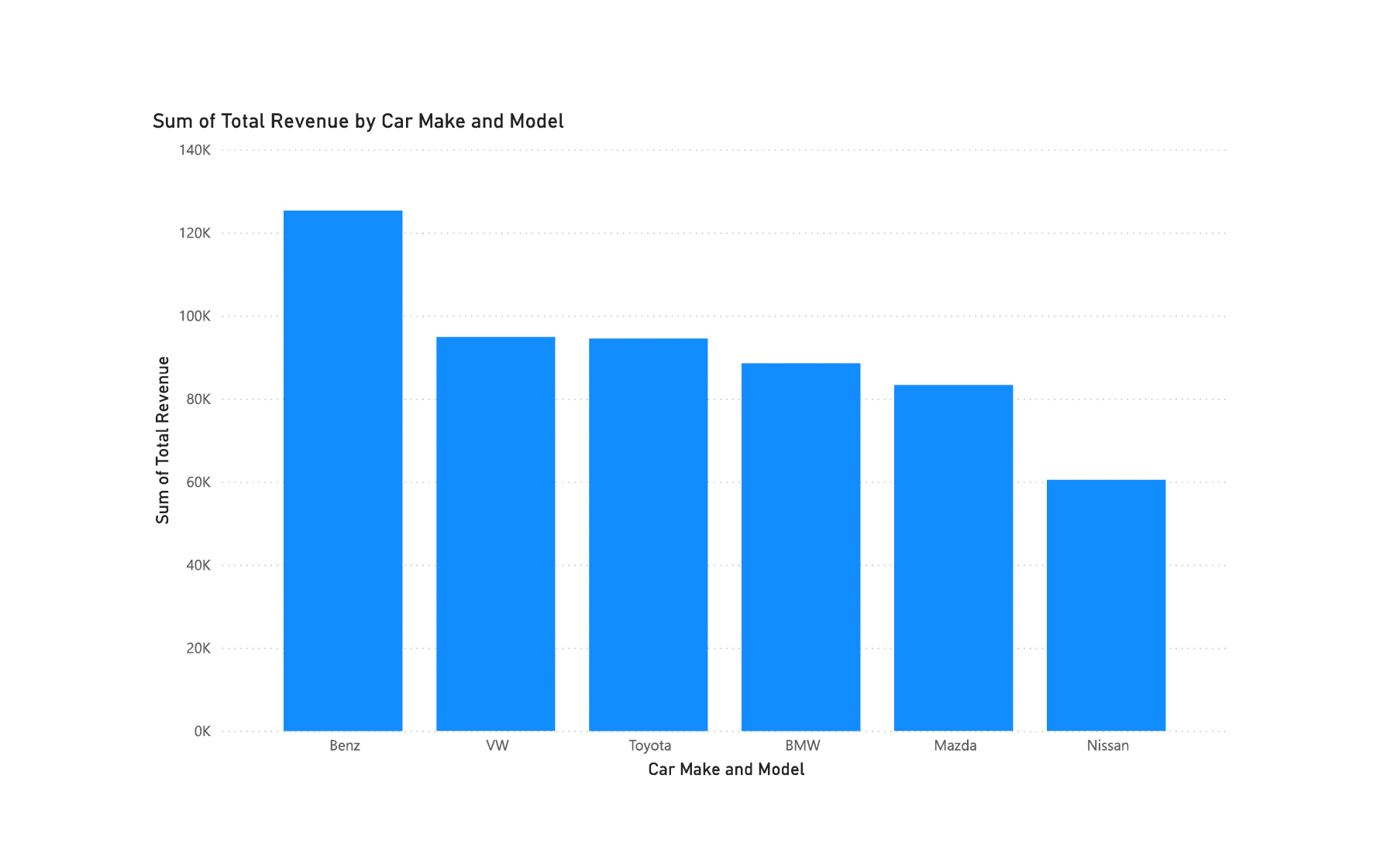

The bar chart illustrates the total revenue generated by different car makes and models in the business. From the chart, the Benz brand generates the highest revenue, surpassing all other brands, indicating a strong customer preference or higher rental rates for this brand. VW and BMW also performs well, contributing significantly to the total revenue, followed by Toyota and Mazda. Nissan, on the other hand, generates the least revenue among the listed brands.

This insight suggests that focusing on maintaining and expanding the fleet of high-performing brands like Benz, VW, and BMW could enhance profitability, while evaluating the strategies for lower-performing brands like Nissan might be necessary to improve their revenue contribution.

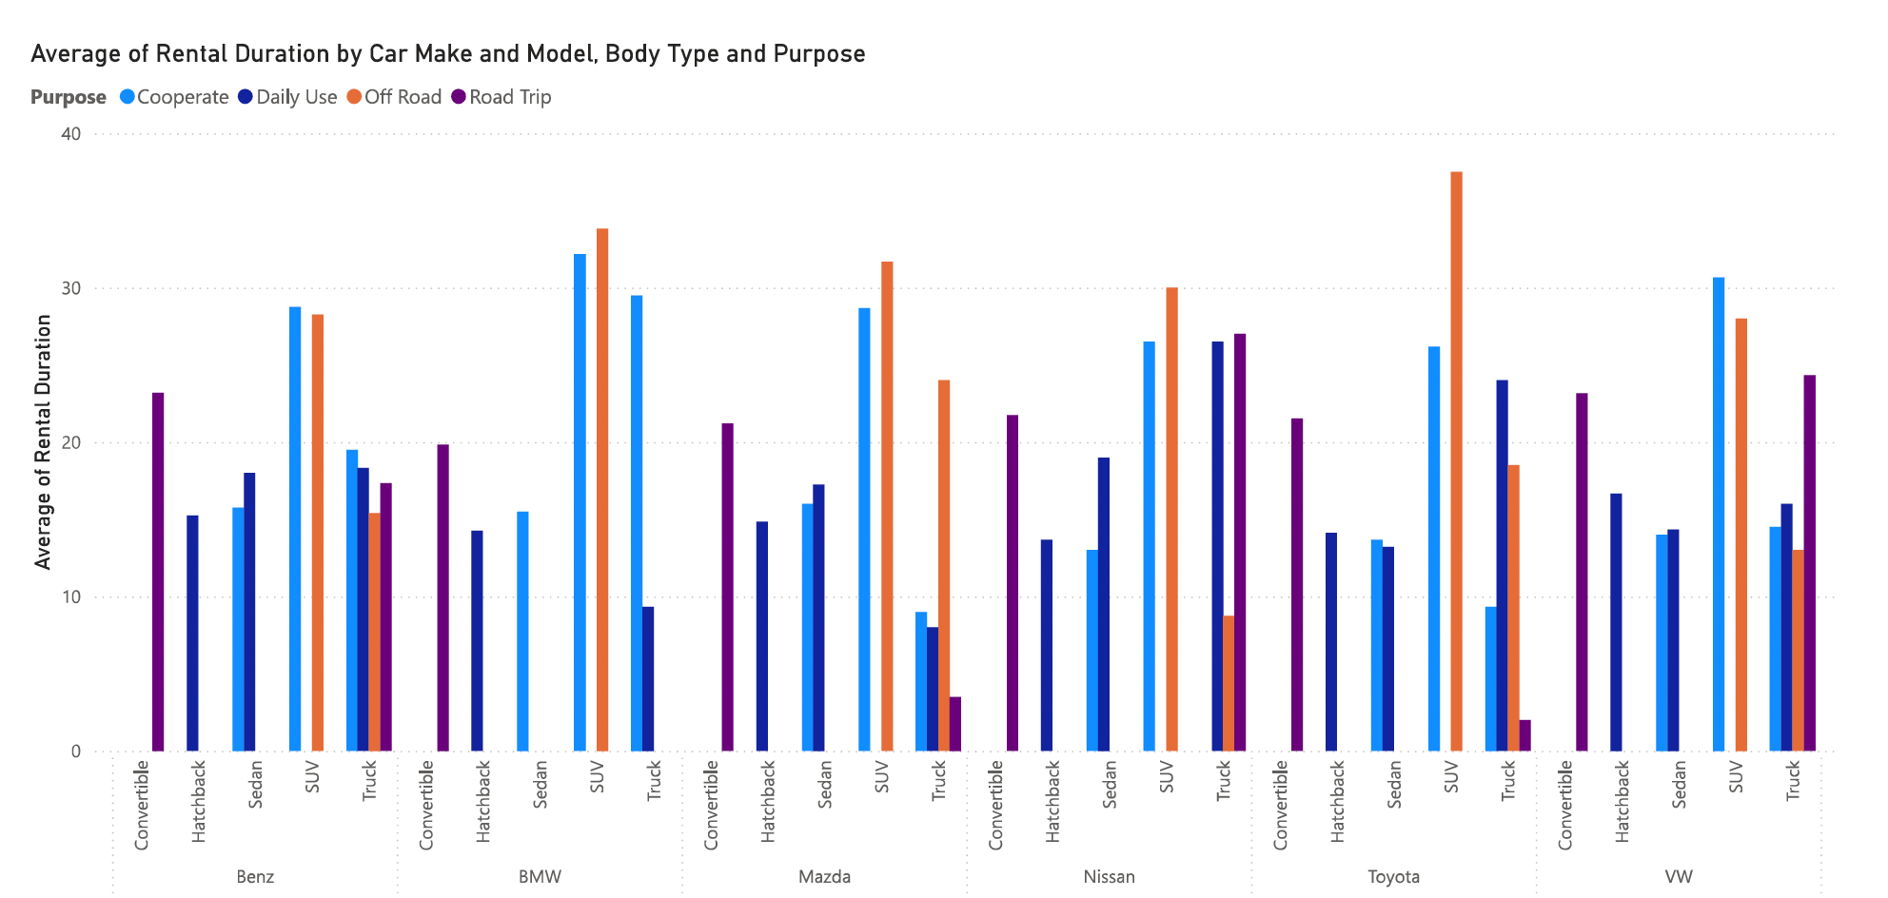

The chart displays the average rental duration for different car makes and models, segmented by body type and rental purpose (Corporate, Daily Use, Off Road, and Road Trip). It reveals that SUVs generally have the longest rental durations across all purposes, especially for off-road and corporate use, indicating a strong preference for this body type in these scenarios. Sedans and trucks also show significant rental durations, particularly for corporate and daily use. Convertibles and hatchbacks tend to have shorter rental durations, suggesting they are less favored for extended use.

This insight can guide the car rental business in optimizing their fleet composition based on customer preferences for different rental purposes, potentially focusing on acquiring more SUVs to meet demand for longer-term rentals.

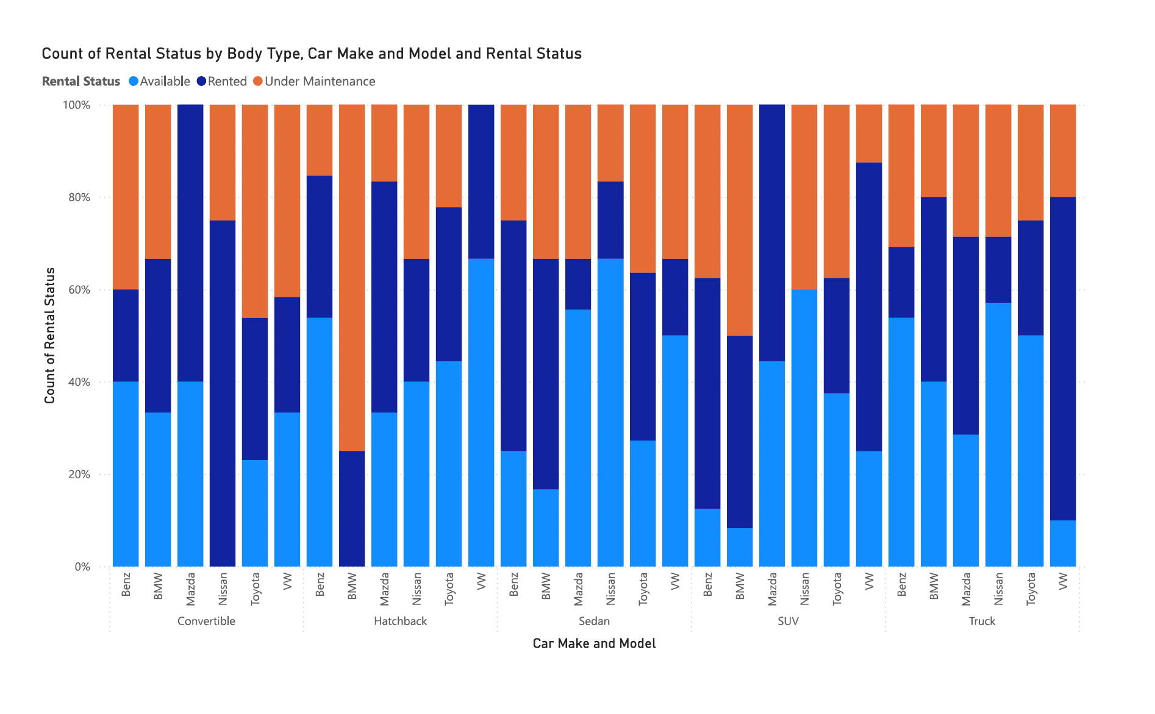

The chart illustrates the rental status distribution (Available, Rented, Under Maintenance) by body type, car make, and model. It shows that SUVs and sedans have a higher proportion of vehicles rented out, indicating strong customer demand for these body types. Convertibles and hatchbacks, on the other hand, show a higher percentage of vehicles available, suggesting lower demand or oversupply. The proportion of vehicles under maintenance varies across different makes and models, with some brands like Mazda and BMW having a significant portion of their fleet under maintenance, highlighting potential reliability or upkeep issues.

This insight can help the business optimize its fleet composition and maintenance schedules to better match customer demand and improve fleet utilization.

**RECOMMENDATIONS**

From the insights gained, it’s prudent for the business to;

Firstly, given the high revenue generated by brands like Benz, VW, and BMW, the business should consider expanding its fleet of these high-performing brands. This strategy would capitalize on customer preferences and potentially increase profitability. Additionally, the data indicates that SUVs and sedans are in high demand, particularly for longer rental durations and various purposes such as corporate use, daily use, and off-road trips. Increasing the inventory of these vehicle types could meet customer demand more effectively and reduce instances of unavailable vehicles, thereby improving customer satisfaction.

Secondly, the chart showing rental status by car make and model reveals that certain brands, like Mazda and BMW, have a significant portion of their fleet under maintenance. This suggests a need for enhanced maintenance practices or a reevaluation of the brands being stocked. Implementing a more proactive maintenance schedule and investing in more reliable vehicle brands could minimize downtime and ensure a higher availability rate for rentals. The business should also consider periodic fleet reviews to phase out high-maintenance vehicles and replace them with more dependable options, ensuring continuous availability and operational efficiency.

**BI Report and Dashboard Design**

**Design and Development of the BI Dashboard**

The dashboard was meticulously designed to provide real-time insights into rental trends, customer behavior, and financial performance. Power BI was selected as the primary BI tool for its robust visualization capabilities.

**Description of the Chosen BI Tools and Technologies**

Power BI was chosen for its user-friendly interface and powerful data visualization features, which enabled the creation of interactive and easily navigable dashboards. This choice was driven by the need for a tool that could seamlessly integrate with various data sources, allowing for real-time data analysis and reporting. Power BI's extensive customization options and robust analytical capabilities make it an ideal solution for transforming raw data into insightful visualizations. These features empower the business to monitor key performance indicators, identify trends, and make informed decisions with greater efficiency and clarity. Additionally, Power BI's cloud-based platform facilitates easy sharing and collaboration among team members, ensuring that stakeholders have access to up-to-date information anytime, anywhere.

**Dashboard Features and Functionalities**

Key features of the dashboard included rental trend analysis, customer demographics, and financial performance metrics. The dashboard provided real-time data updates and customizable views tailored to different user roles.

**Considerations for Implementation**

Considerations for implementation included selecting appropriate tools, ensuring scalability, and providing user training. The implementation plan was designed to ensure the dashboard's ability to grow with the company's evolving needs and included comprehensive staff training.

**Implementation Plan**

**Steps for Implementing the BI Dashboard in the SME**

1. **Data Integration:** Consolidate rental transaction records, customer feedback, and financial data into a central database.
2. **Dashboard Development:** Develop data visualizations in Power BI, focusing on rental trends, customer demographics, and financial performance.
3. **User Training:** Conduct training sessions for staff to ensure effective use of the dashboard, supported by user manuals and training materials.
4. **Testing and Validation:** Perform user acceptance testing (UAT) to verify that the dashboard meets business requirements.
5. **Deployment:** Launch the dashboard and continuously monitor its performance, gathering feedback for ongoing improvement.

**Training and Support for SME Staff**

Comprehensive training sessions were conducted to ensure all staff could effectively utilize the dashboard. These sessions were designed to cover all aspects of Power BI, from basic navigation to advanced data analysis and visualization techniques. Customized training materials and user guides were provided to support this effort, tailored to address the specific needs and skill levels of the staff. By equipping employees with the necessary knowledge and tools, the training aimed to foster confidence and competence in using the dashboard, ultimately enhancing their ability to make data-driven decisions and contribute to the business’s success.

**Recommendations for Ongoing Use and Maintenance**

Regular updates and continuous training were recommended to keep the dashboard relevant and adaptable to the company's changing needs. These updates ensure that the dashboard incorporates the latest data, features, and analytical capabilities, providing users with the most accurate and up-to-date information. Continuous training helps staff stay proficient with new functionalities and best practices, fostering a culture of ongoing learning and improvement. By maintaining an adaptable and current BI environment, the company can better respond to evolving business challenges and opportunities, ensuring sustained effectiveness and value from their Power BI investment.

**Detailed User Guide for the BI Dashboard**

Welcome to the Superb Motors Power BI Dashboard! This guide will help you understand how to use the dashboard effectively to gain insights into our business performance.

2. Getting Started

Installing Power BI Desktop

If you haven't already, you'll need to install Power BI Desktop to view the dashboard. Follow these steps:

1. Go to the [Power BI download page](https://powerbi.microsoft.com/desktop/).

2. Download and install the application.

Opening the Dashboard

1. Open Power BI Desktop.

2. Click on "File" in the top-left corner.

3. Select "Open" and navigate to the location where the Superb Motors. pbix file is saved.

4. Select the file and click "Open."

3. Navigating the Dashboard

Main Screen

When you open the dashboard, you will see the main screen which includes various reports and visualizations. The main components are:

* Ribbon: Contains options for file operations, data refresh, and other tools.
* Pages Pane: Located at the bottom, this allows you to switch between different pages of the report.
* Visualizations Pane: On the right, it shows available visualizations and customization options.
* Fields Pane: Lists the data fields available for creating and modifying visuals.

Pages

The dashboard is divided into multiple pages, each focusing on different aspects of Superb Motors' business. The pages include:

* **Revenue Analysis Page :**
  + Overview of the company's Revenue metrics.
  + Key chart: Total Revenue by Car Make and Model.
* **Revenue by Purpose Page:**
  + Insights into the car fleet, of revenue by car make and model, and a slicer for body type.
  + Key chart: Total Revenue By Purpose, ‘Car Make and Model’ and ‘Body type’.
* **Cost By Purpose Page:**
  + Insights into the car fleet, of cost by car make and model, and a slicer for body type.
  + Key chart: Total Cost By ‘Car Make and Model’, ‘Body type’ and Purpose.
* **Cost and Revenue Page:**
  + Comprehensive financial metrics of the total cost and total revenue by car make and model.
  + Key charts: Sum of Total Cost and Sum of Total Revenue by ‘Car Make and Model’ and ‘Body type’.
* **Customer Preferences Page:**
  + Analysis of customer preference on ‘Body Type’, make and Model’ based on the car’s purpose for rental.
  + Key charts: ‘Make and Model’, ‘Body Type’ and ‘Purpose’(the client’s intent for renting).
* **Average Rental Car Duration Page:**
  + Chart showing the average rental duration by ‘Make and Model’ and ‘Body Type’.
  + Key charts: ‘Make and Model’, ‘Body Type’ and ‘Average Rental Duration’.
* **Customer Rating** **Page:**
  + Chart showing the average Customer Rating based on their experience with the car by ‘Make and Model’ and ‘Customer Rating’.
  + Key charts:‘Make and Model’, ‘Body Type’ and ‘Customer Rating’.
* **Operational Efficiency Page:**
  + Comprehensive bar chart showing the status of a car including rented, under maintenance, and available.
  + Key charts: ‘Make and Model’, ‘Body Type’ and Count of Rental Status.

4. Understanding Dashboard Elements

Visualizations

Each page contains various Bar Chart visualizations to easily compare values across categories.

5. Common Tasks

Interacting with Visuals

* Hover Over Visuals: Hover your mouse over a visualization to see detailed information.
* Click to Drill Down: Click on a data point to see more detailed information related to that point.
* Right-Click Options: Right-click on visuals for additional options, such as drilling down or exporting data.

Using Slicers:

Body type Slicer:

* Located on the Revenue by Purpose, Cost By Purpose, Cost and Revenue, Customer Preferences, Average Rental Car Duration, and Customer Rating Pages.
* Used to filter data by specific car makes and models.

Car Make/Model Slicer:

* Located on the Operational Efficiency Page.
* Used to filter data by specific car makes and models.

Exporting Data

To export data from a visualization:

1. Click on the visualization you want to export.

2. Click on the "More options" button (three dots) in the top-right corner of the visualization.

3. Select "Export data" and choose your preferred file format (e.g., Excel).

6. Tips and Best Practices

* Save Your Work: Regularly save your changes to avoid losing any customizations.
* Use Bookmarks: Create bookmarks for frequently used views to easily return to them.
* Explore Interactivity: Experiment with different filters and visuals to discover new insights.

7. Troubleshooting

Common Issues

* Slow Performance: Ensure your computer meets the system requirements for Power BI Desktop.
* Data Not Refreshing: Click the "Refresh" button in the ribbon to update the data.
* Missing Visuals: Make sure all necessary data sources are connected and the report is fully loaded.

Getting Help

For additional support, visit the Power BI Community or refer to the [Power BI Documentation](https://docs.microsoft.com/en-us/power-bi/).

**Feedback and Evaluation**

Feedback was collected through surveys and interviews with staff at Superb Motors, revealing valuable insights into the effectiveness of the BI dashboard. Users consistently appreciated the real-time insights provided by the dashboard, noting that it significantly enhanced their ability to make informed decisions quickly. The intuitive and user-friendly interface was highlighted as a major strength, making it accessible to staff members with varying levels of technical expertise. Additionally, many users reported that the dashboard's customizable views and interactive features improved their workflow efficiency and allowed for better tracking of key performance indicators. Overall, the positive feedback underscores the dashboard's role in transforming data into actionable insights, thereby supporting the company's strategic goals.

**Analysis of the Feedback and Suggested Improvements**

The analysis of feedback from Superb Motors staff highlighted a few areas for improvement, primarily focusing on the need for additional training and specific feature enhancements. While users found the dashboard intuitive and beneficial, some expressed a desire for more in-depth training sessions to fully leverage the advanced functionalities of the BI tools.

Additionally, suggestions for feature enhancements included more detailed data filtering options, improved visualization capabilities, and better integration with existing systems for seamless data flow.

In response, these recommendations will be promptly incorporated into subsequent dashboard updates. Enhanced training programs will be developed to address knowledge gaps, and new features will be added to improve usability and functionality, ensuring the dashboard continues to meet the evolving needs of the business.

**Future Recommendations**

**Recommendations for Further Development of the SME's BI Capabilities**

Future recommendations included integrating predictive analytics and machine learning to anticipate trends and optimize resource allocation.

**Suggested Additional BI Tools and Techniques**

To further enhance the BI capabilities of Superb Motors, integrating advanced tools and techniques such as Microsoft Azure Machine Learning and Google Cloud AutoML can provide powerful predictive analytics and machine learning capabilities. Implementing data warehousing solutions like Amazon Redshift and Snowflake will streamline data storage and retrieval, improving data management efficiency.

Advanced data visualization tools like Tableau and Qlik Sense can create more interactive and detailed visual representations, aiding in deeper insights. Data integration and ETL tools such as Talend and Apache Nifi will ensure consistent and real-time data updates. Additionally, integrating CRM systems like Salesforce and HubSpot will enhance customer data analysis, enabling more personalized services and improving customer satisfaction. These enhancements will drive strategic, data-driven decisions, optimizing operations and positioning the company for sustained growth.

**Conclusion**

**Summary of the Project Outcomes**

The implementation of the Business Intelligence (BI) dashboard at Superb Motors has marked a significant milestone in the company's journey toward data-driven decision-making and operational excellence. The comprehensive assessment of BI maturity highlighted critical gaps in data management, technological utilization, and organizational processes, which were effectively addressed through targeted interventions. The deployment of the Power BI dashboard has enabled real-time insights into rental trends, customer preferences, and financial performance, empowering the management team to make informed decisions swiftly. This transition from instinct-based to evidence-based decision-making has not only optimized fleet utilization and reduced downtime but also significantly enhanced customer satisfaction by aligning services with market demands.

**Final Thoughts and Reflections on the Project**

Looking ahead, the integration of advanced analytics and machine learning capabilities presents a promising avenue for further enhancing Superb Motors' competitive edge. Continuous investment in BI tools, ongoing staff training, and regular updates to the dashboard will ensure that the company remains agile and responsive to evolving business challenges and opportunities. By maintaining a strong focus on data quality and governance, Superb Motors can sustain the benefits of BI implementation, driving sustained growth and operational efficiency. This project underscores the transformative potential of Business Intelligence for small and medium enterprises, setting a precedent for future digital initiatives within the company.

**References**

Power, D. J. (2019). *Decision support, analytics, and business intelligence*. Business Expert Press.

Davenport, T. H., & Harris, J. G. (2007). *Competing on analytics: The new science of winning*. Harvard Business Review Press.

Gartner. (2020). *Gartner BI & Analytics Summit 2020: Best Practices for Business Intelligence*. Retrieved from Gartner Website.

Few, S. (2012). *Show me the numbers: Designing tables and graphs to enlighten*. Analytics Press.

**Appendices**

To assess the BI maturity of Superb motors using the Gartner BI Maturity Model, the following five questions are some of the questions we asked:

### 1. What is the current level of support and involvement from senior management in BI initiatives?

### 2. How are BI tools and data analytics currently being used across different departments?

### 3. What data governance and quality management practices are in place?

### 4. How are BI initiatives aligned with the overall business strategy and goals?

### 5. What advanced analytics capabilities and predictive modeling tools are being used, and how widespread is their adoption among employees?